Week 4

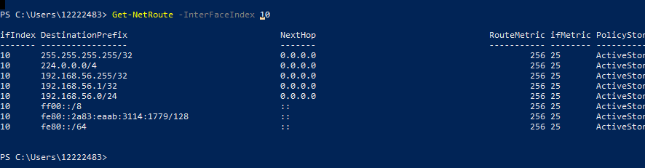





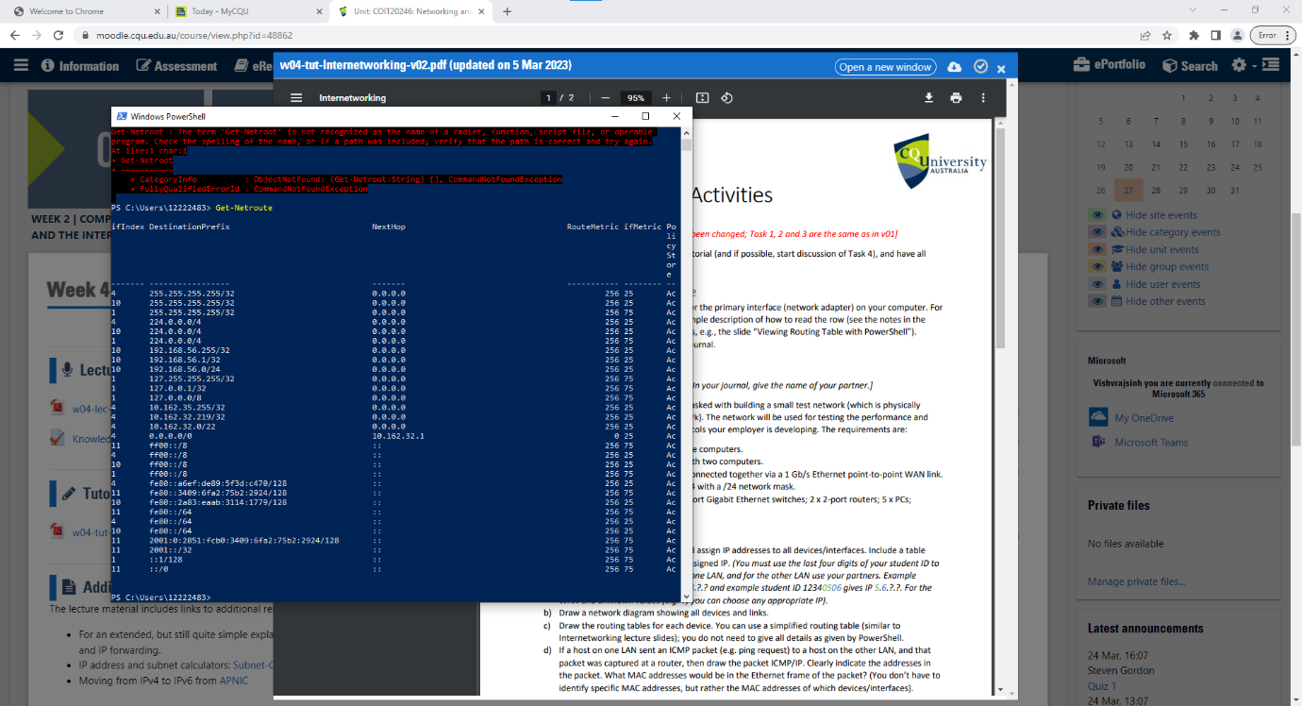

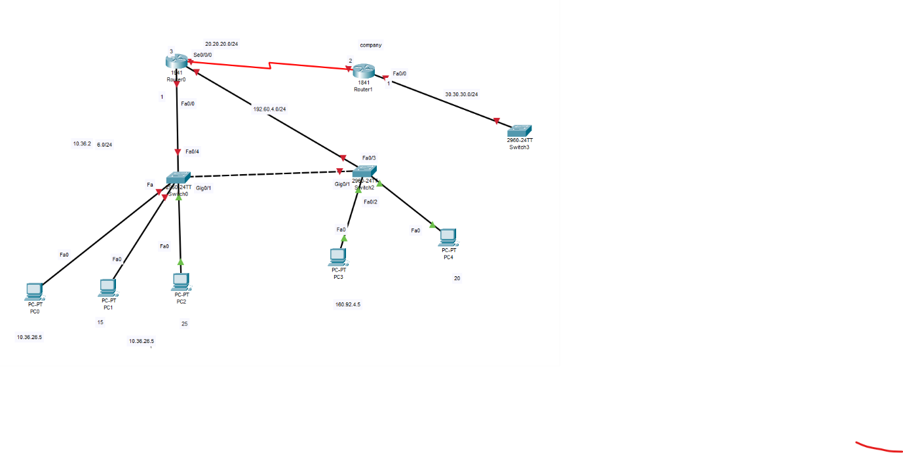

There are a number of things to take into account when deciding whether online services like Google should be used in educational settings, including possible hazards, advantages for students and institutions, and social or ethical concerns. Here are some things to think about:

1. Speed and Communication:

Benefits: With web services like Google, students may collaborate, save, and view files from any device with an internet connection. They also have easy access to a variety of tools and resources.\

* Potential dangers: Students' capacity to work offline or access their personally identifiable information in the event of connectivity problems may be hampered by an over-reliance on web services. When using outside sources to hold sensitive knowledge about education, privacy issues may also arise.

1. Communication and Mutual support

Benefits: By providing real-time collaboration platforms, web services enable students to collaborate on projects, exchange papers, and give comments. They also make it easier for instructors, students, and educational institutions to communicate with one another.

Risks: Due to the potential for the sharing and unauthorised access to personal information and intellectual property, collaborative platforms may give rise to issues about data security and privacy. Misusing communication technologies may also result in concerns with cyberbullying or harassment.

1. Tools and Resources for Education:

Benefits: Web services give users access to a wide range of educational materials, including online libraries, databases for research, and learning tools. These tools can make studying more enjoyable and offer chances for self-paced learning.

Week 5

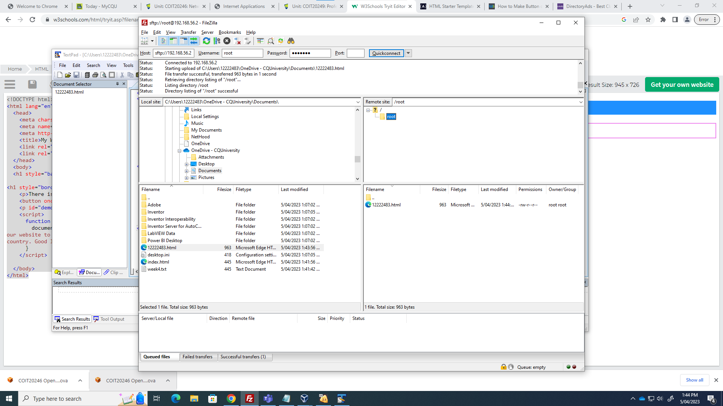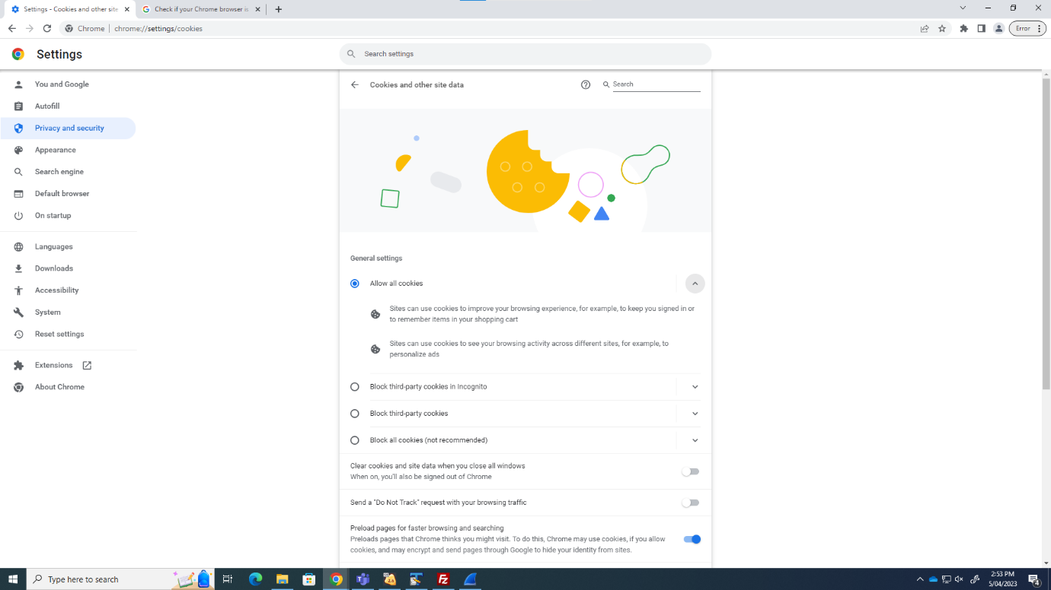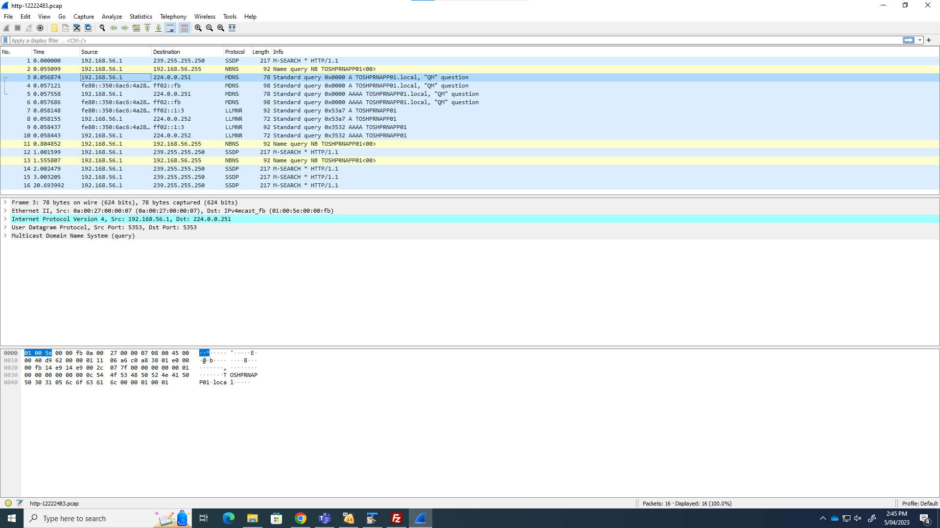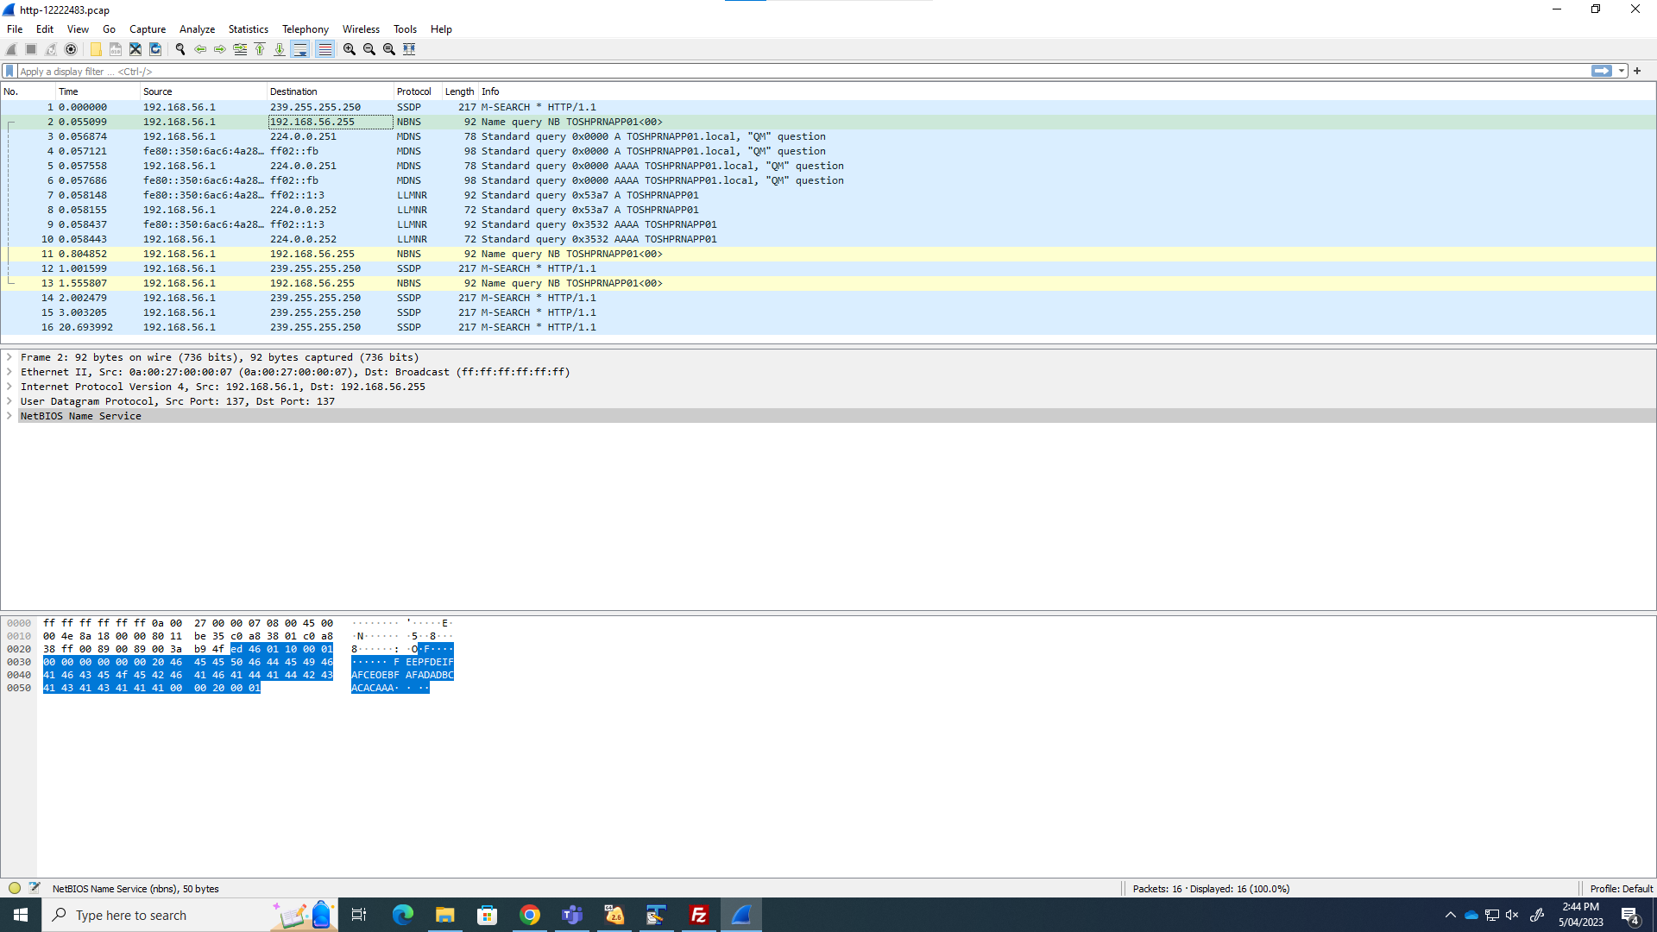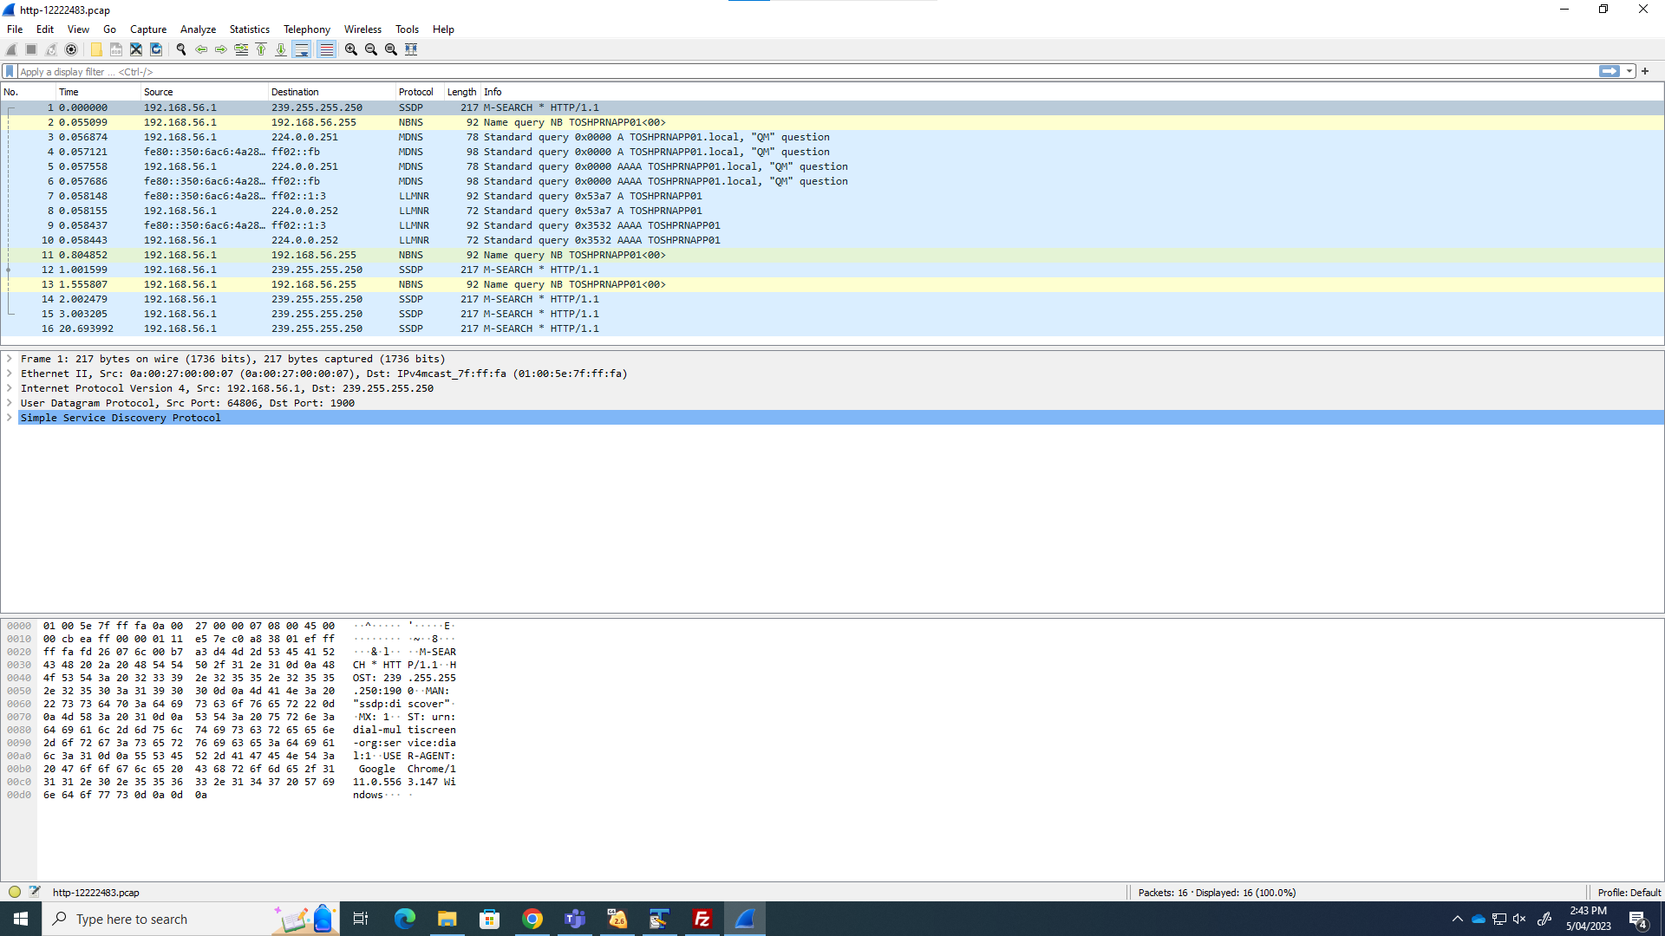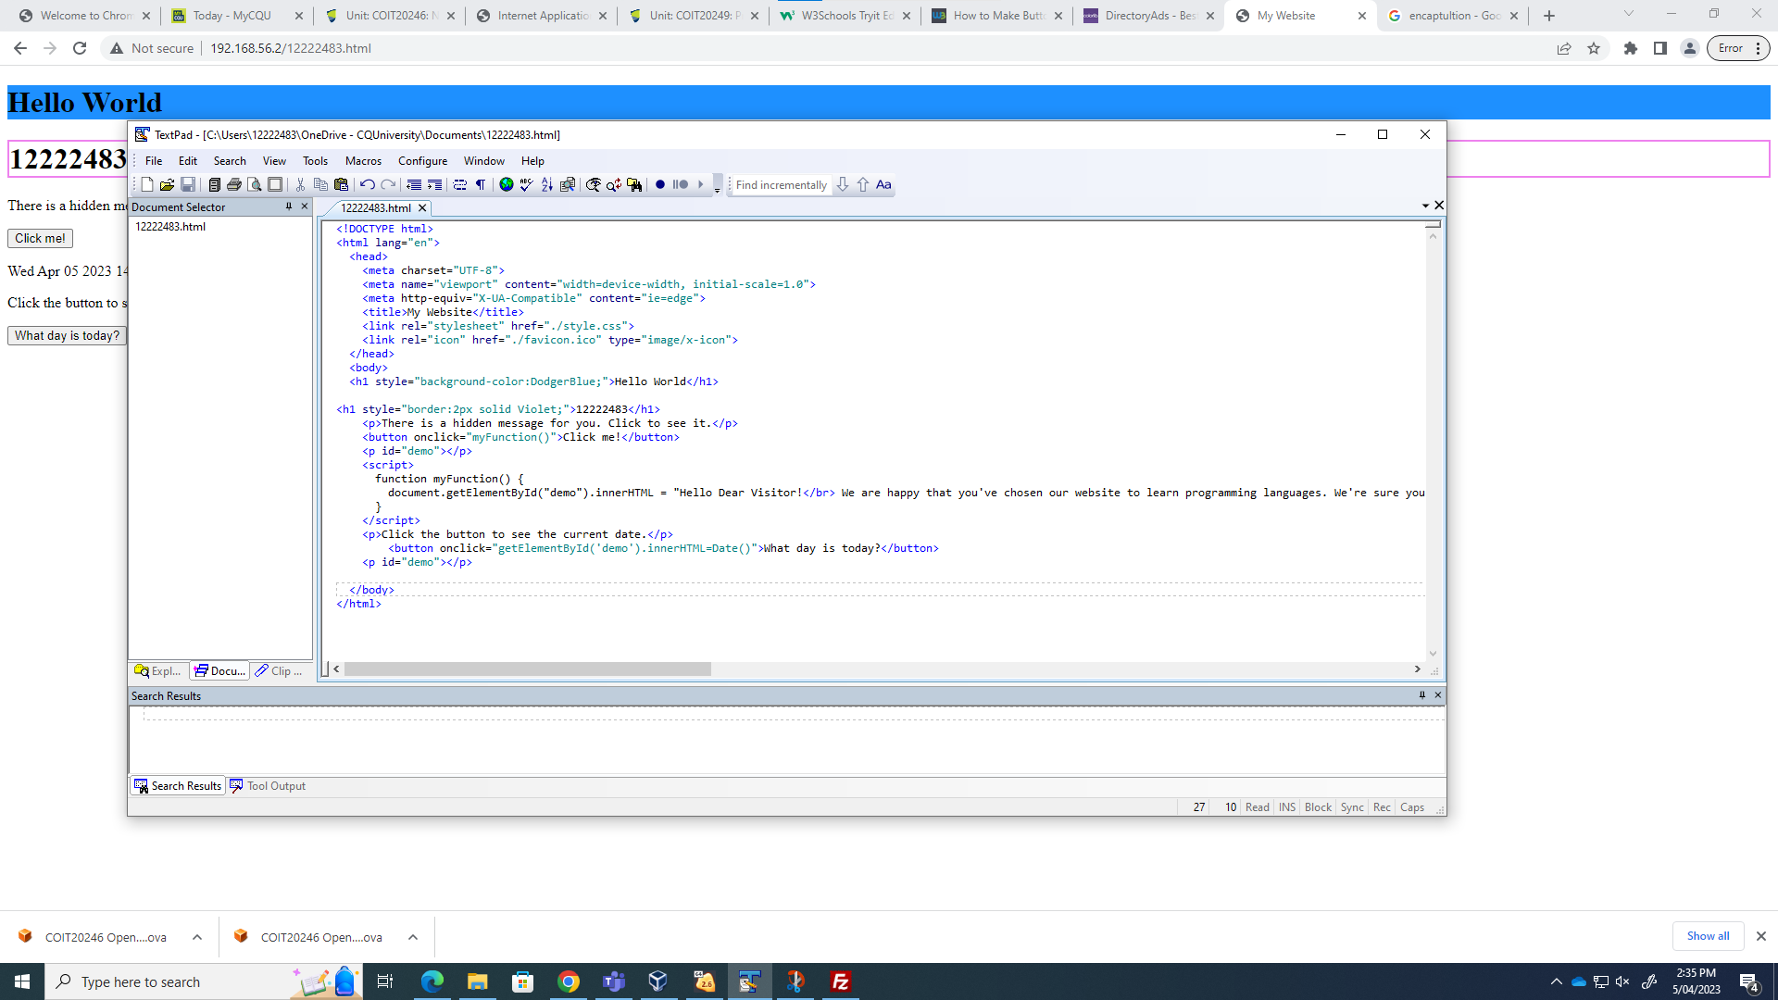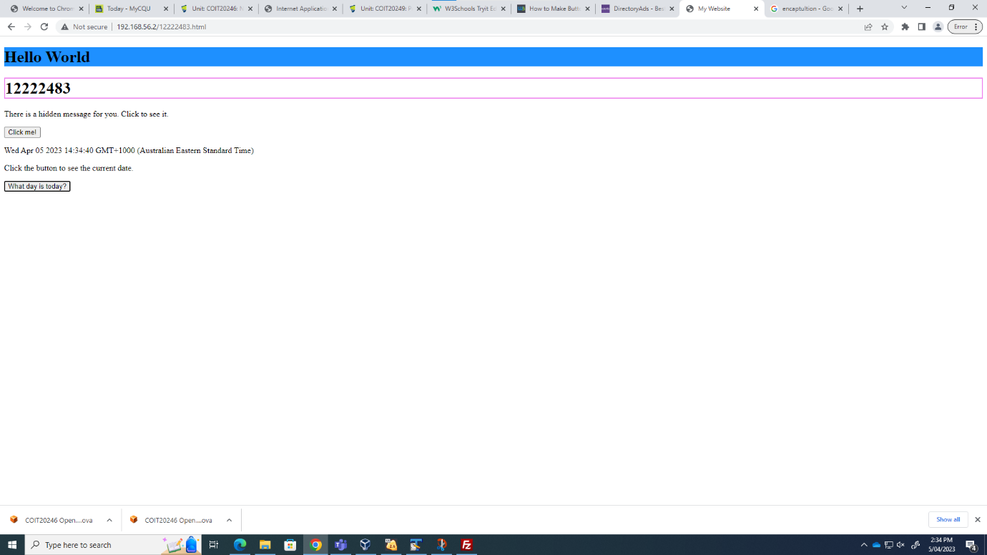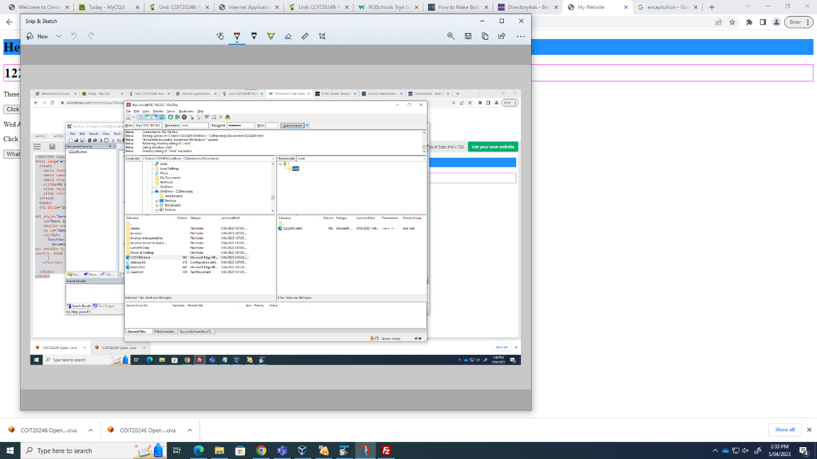

Week 6

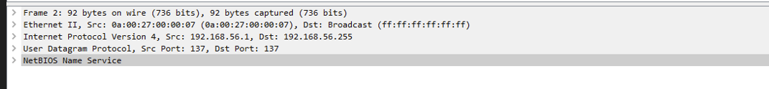

Week 7

Task 1&2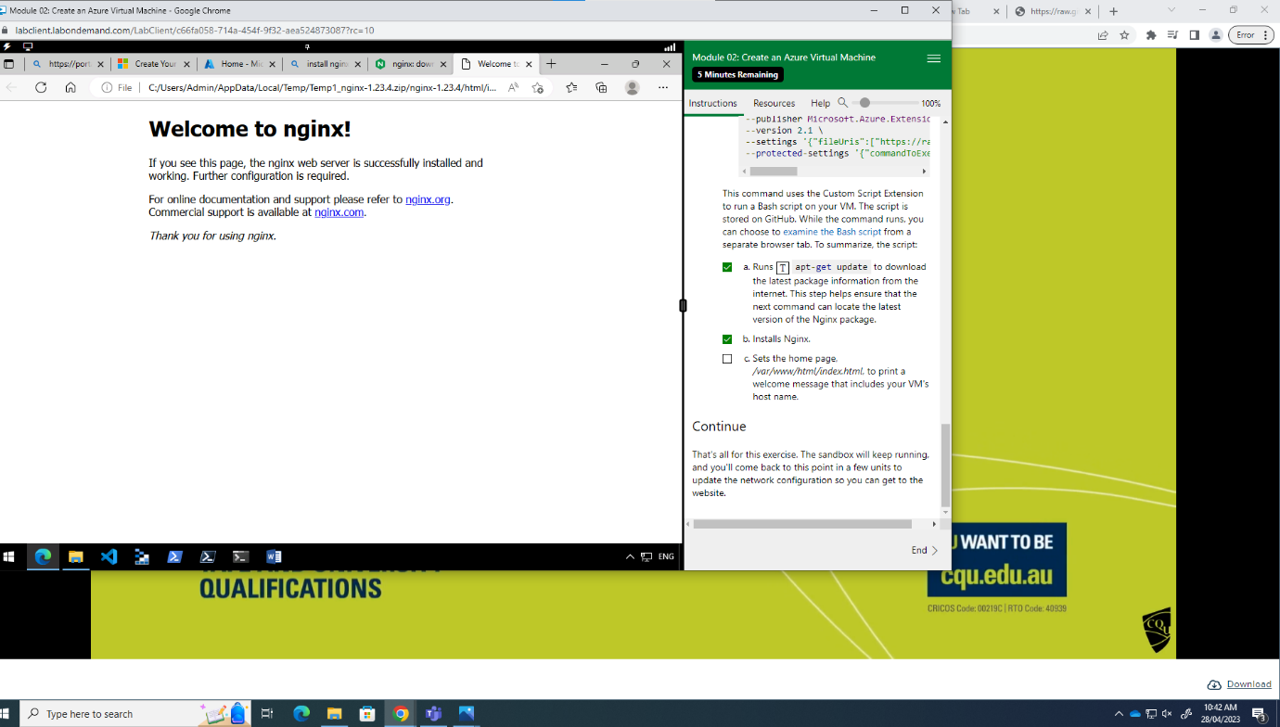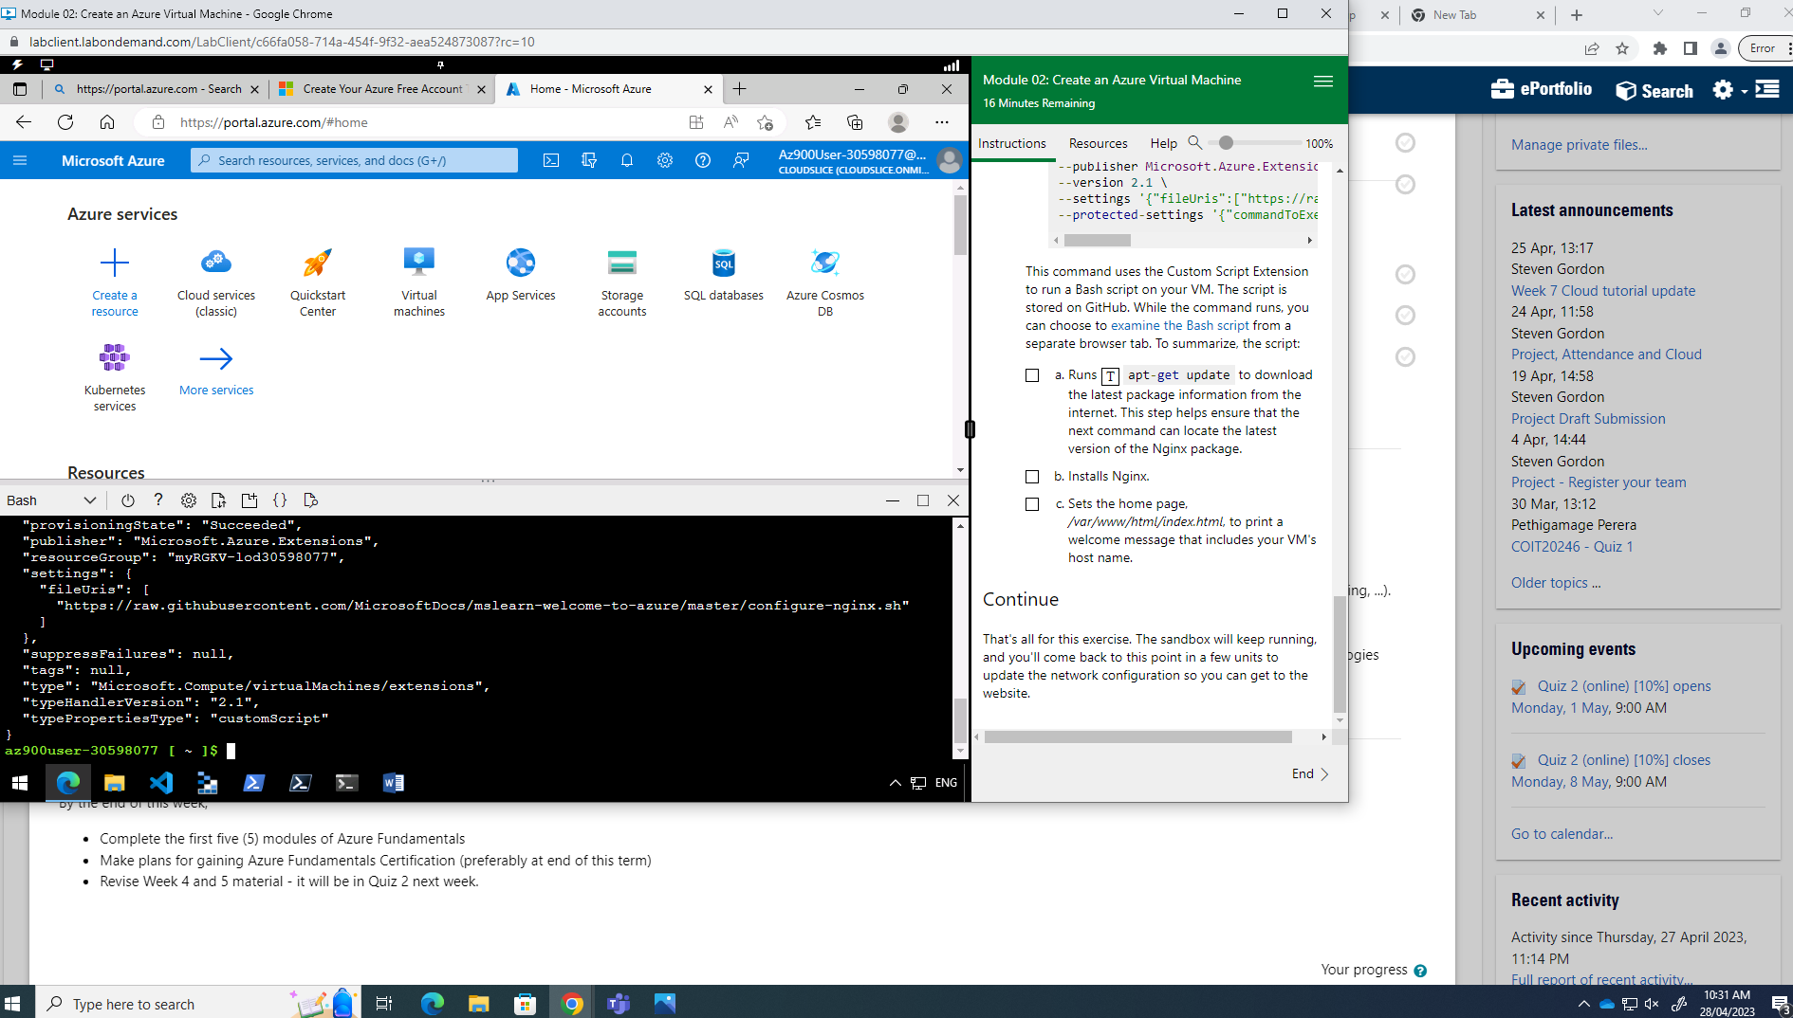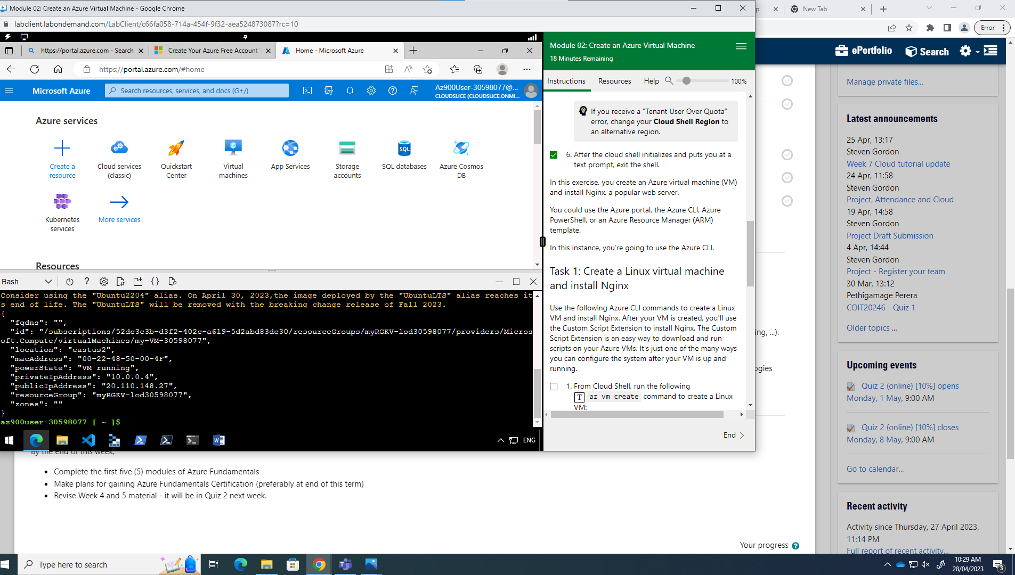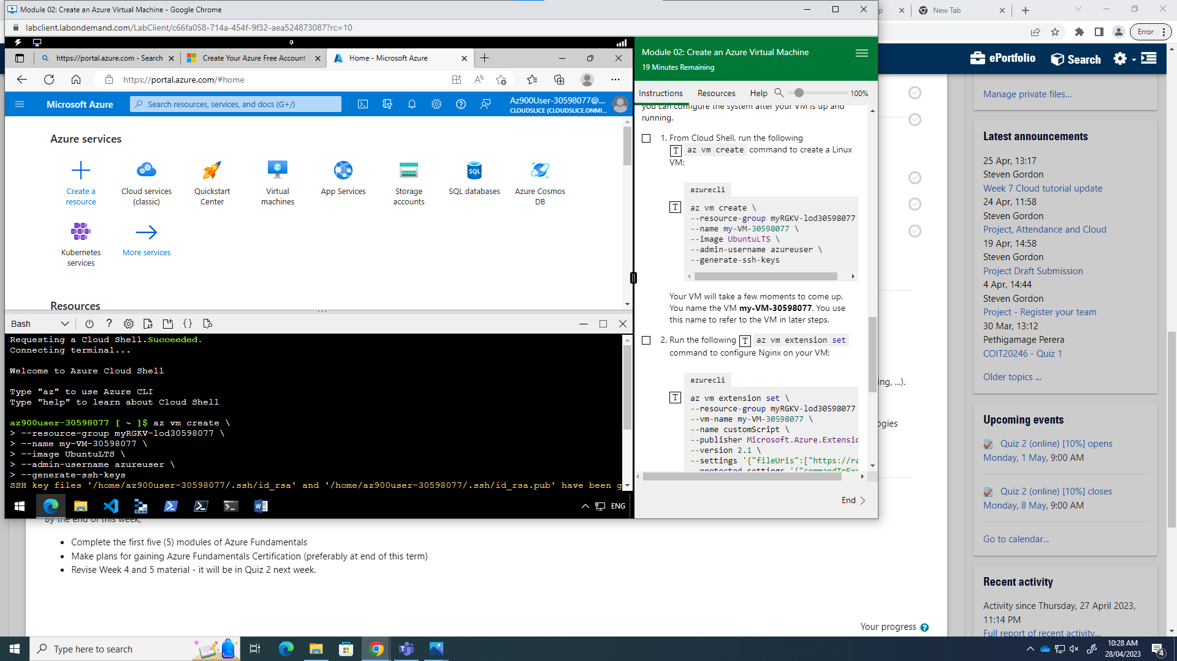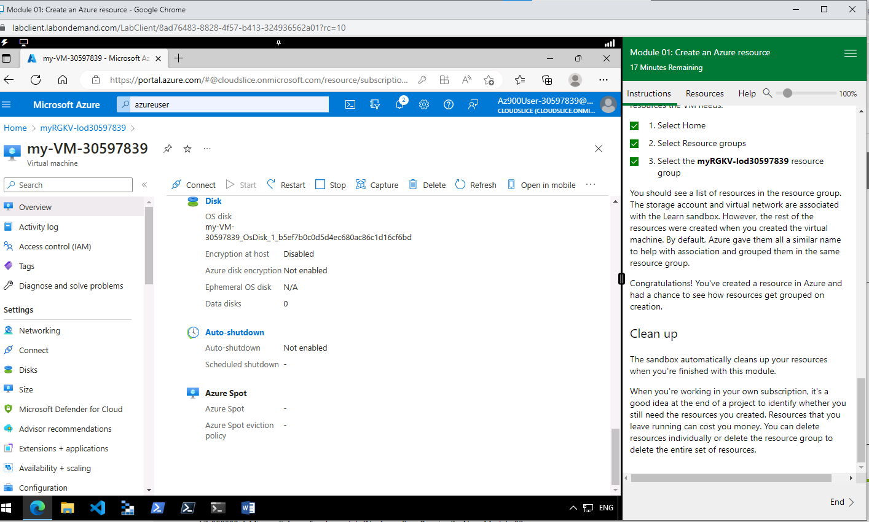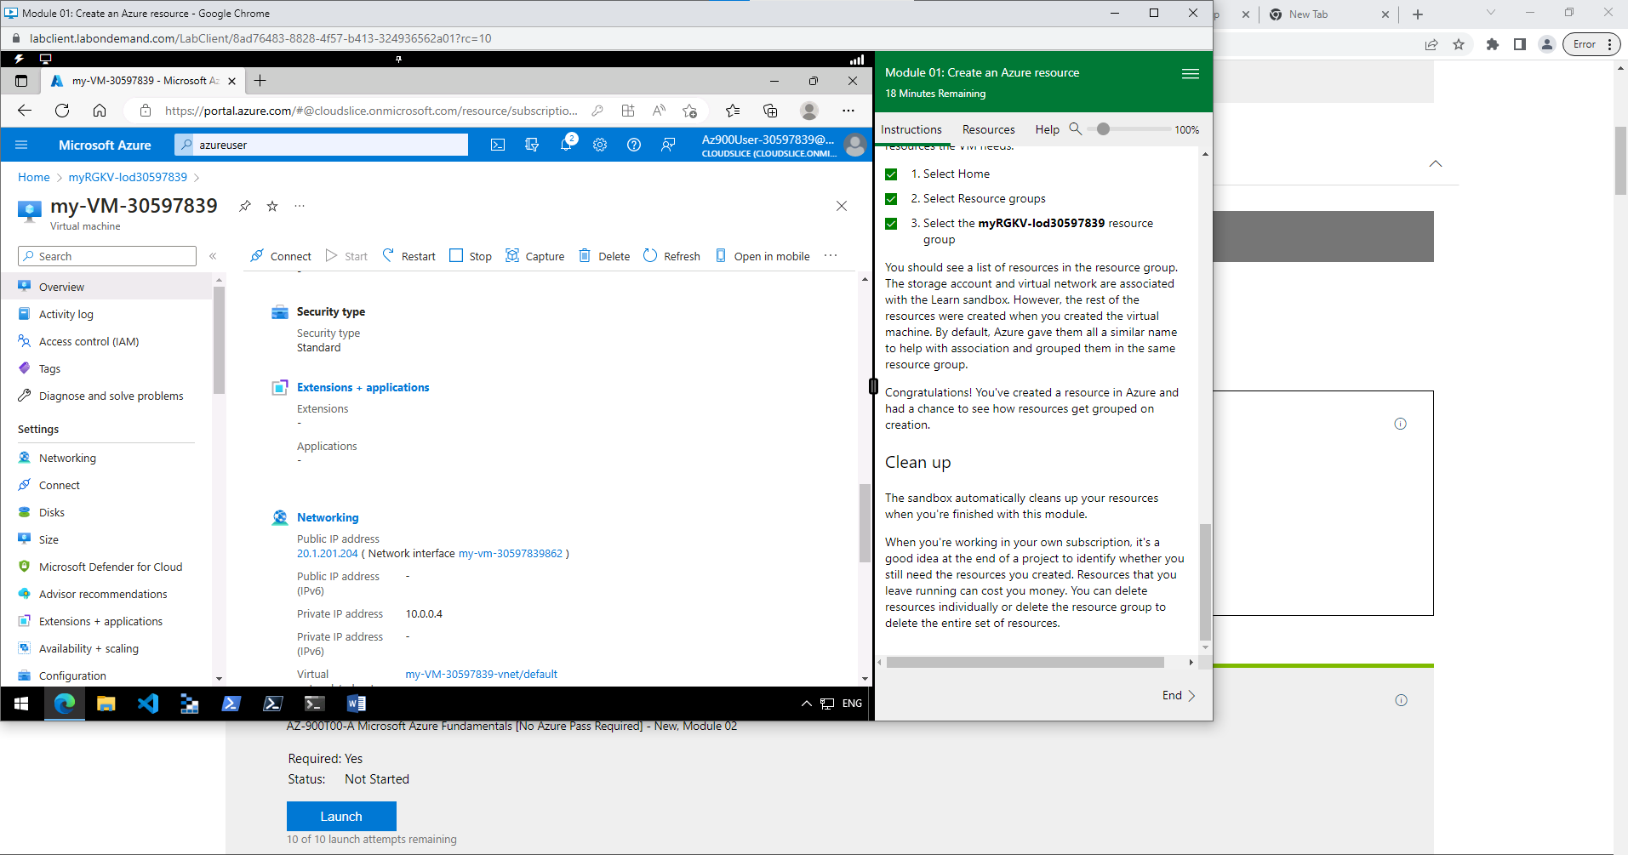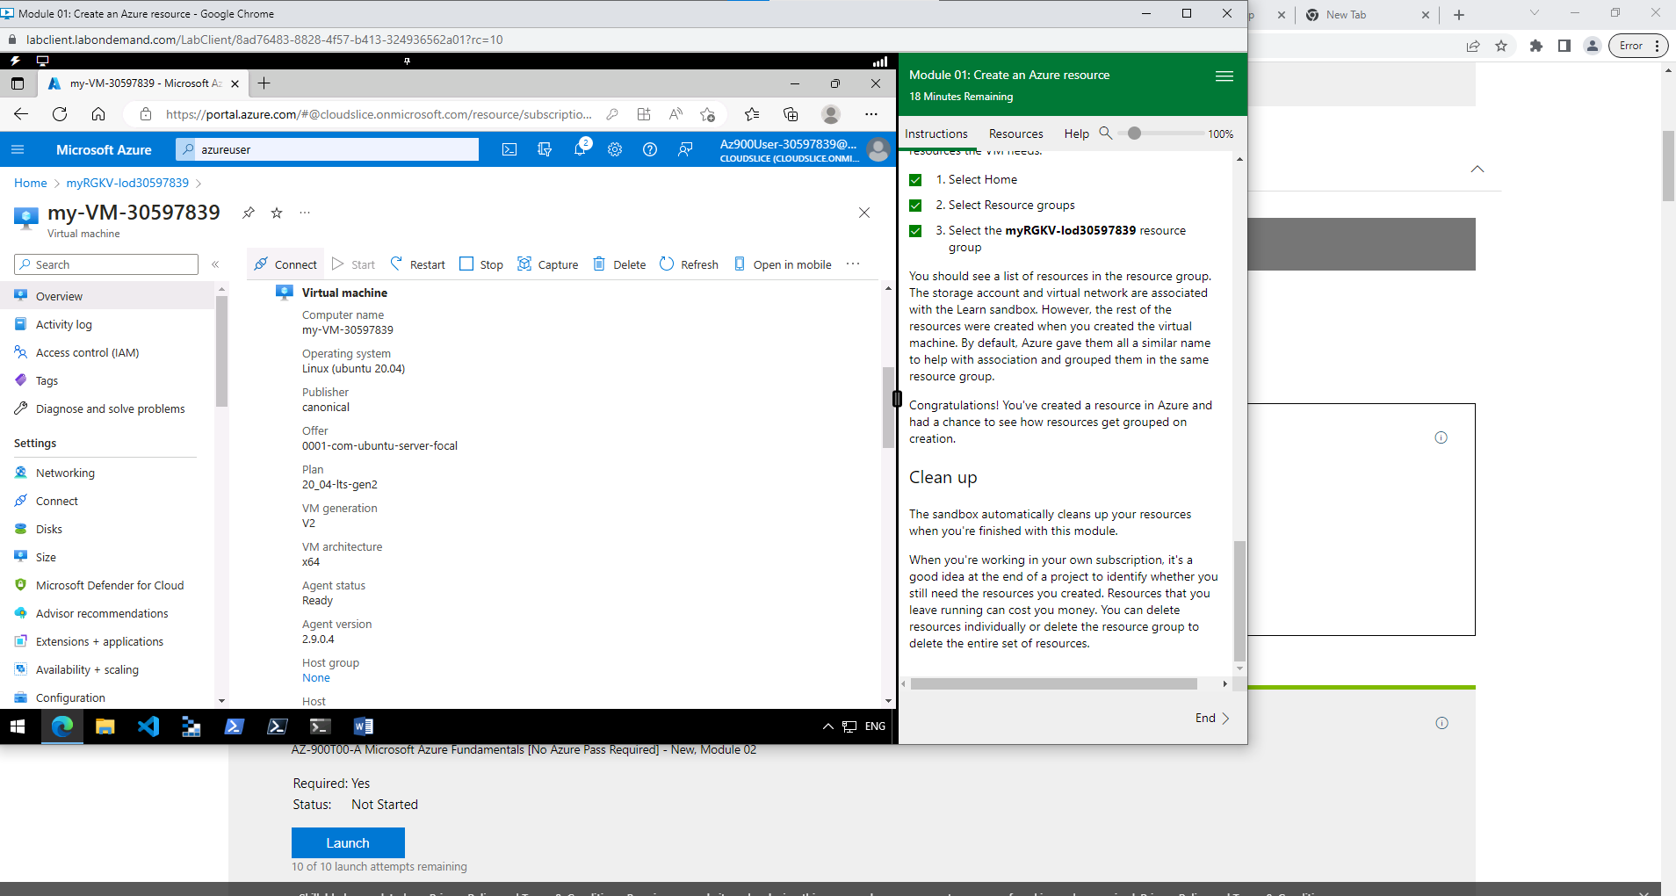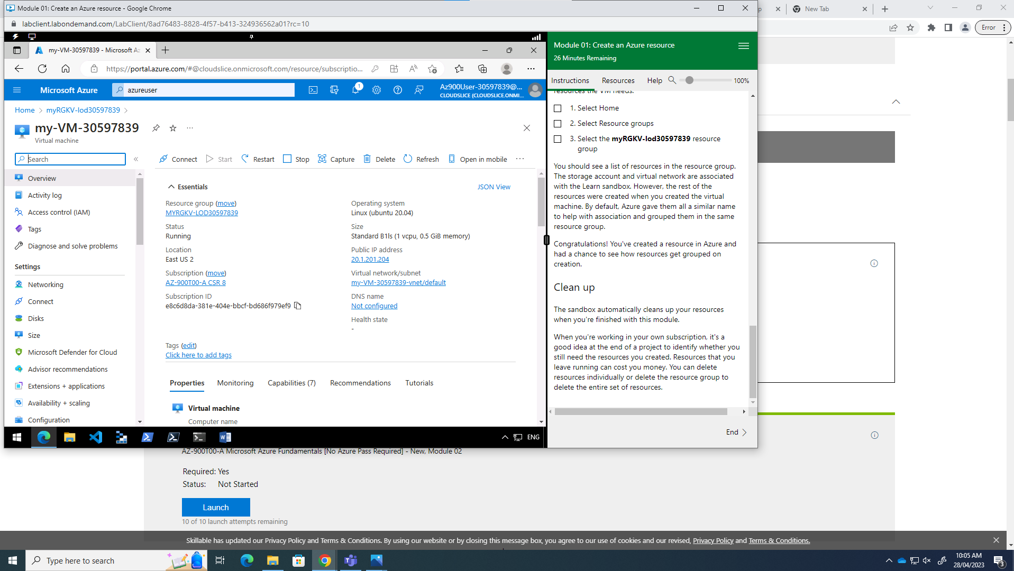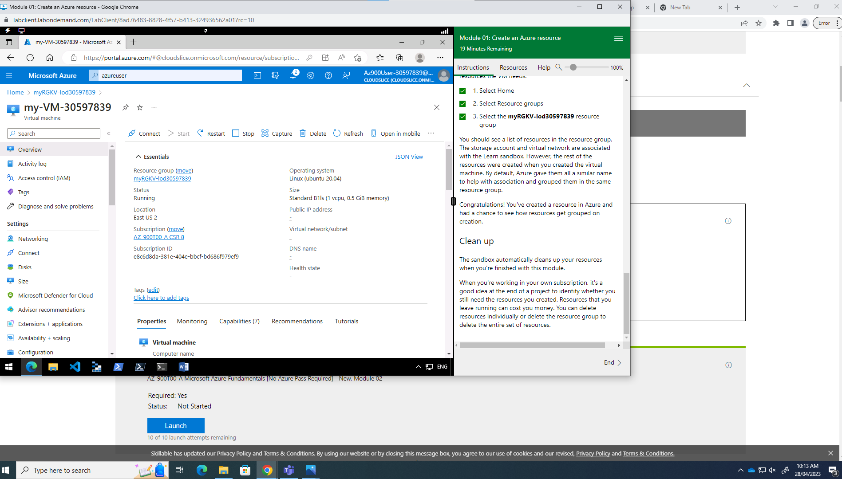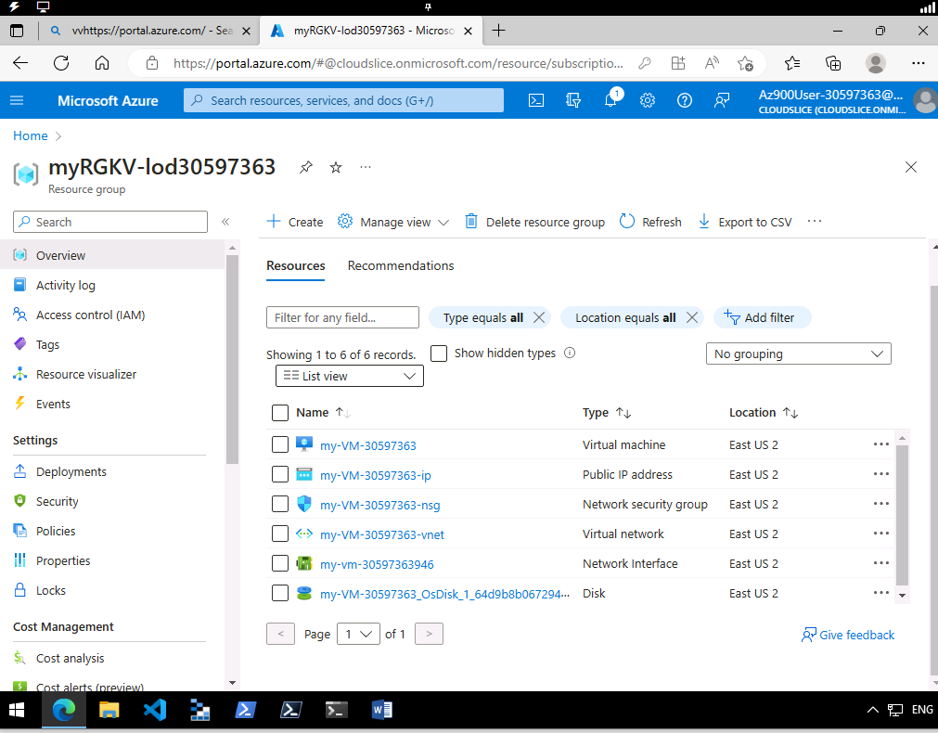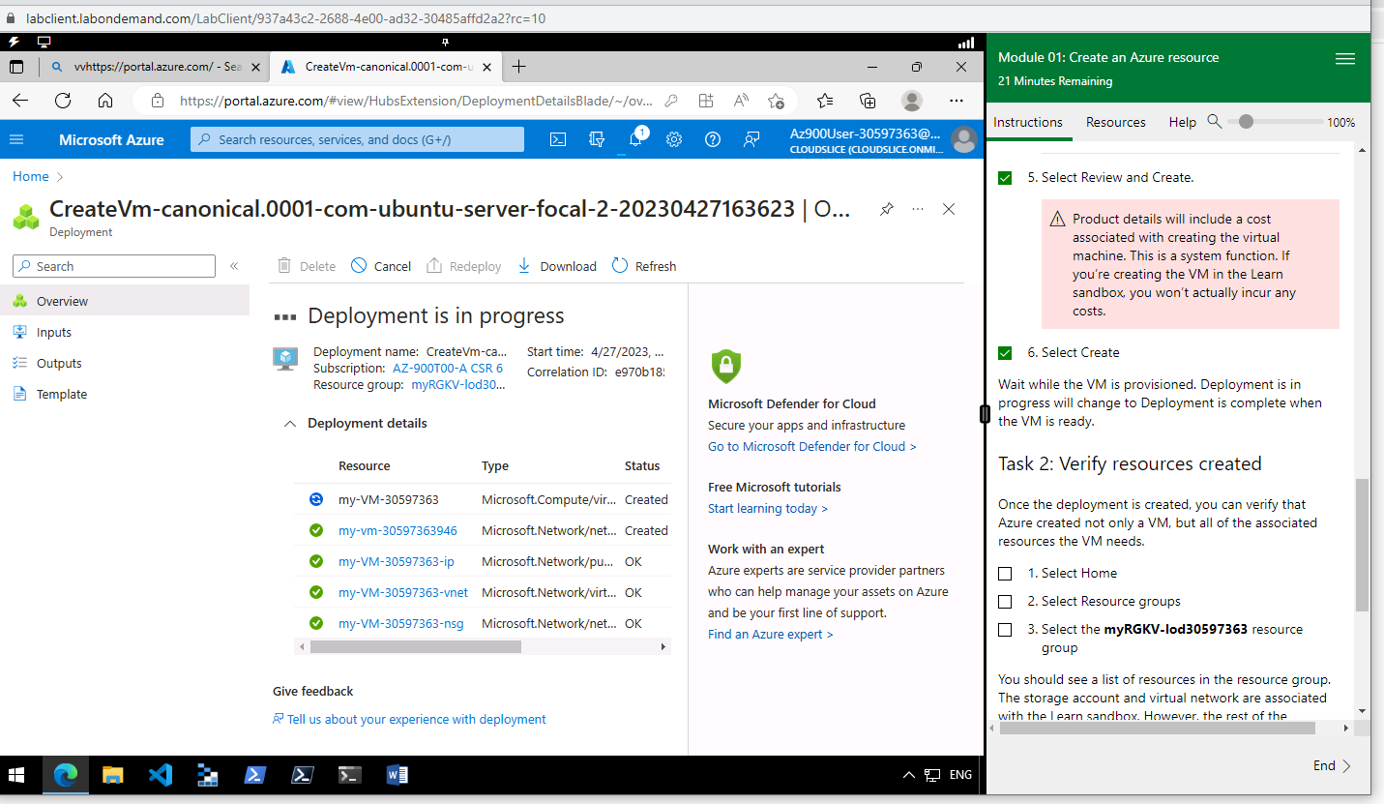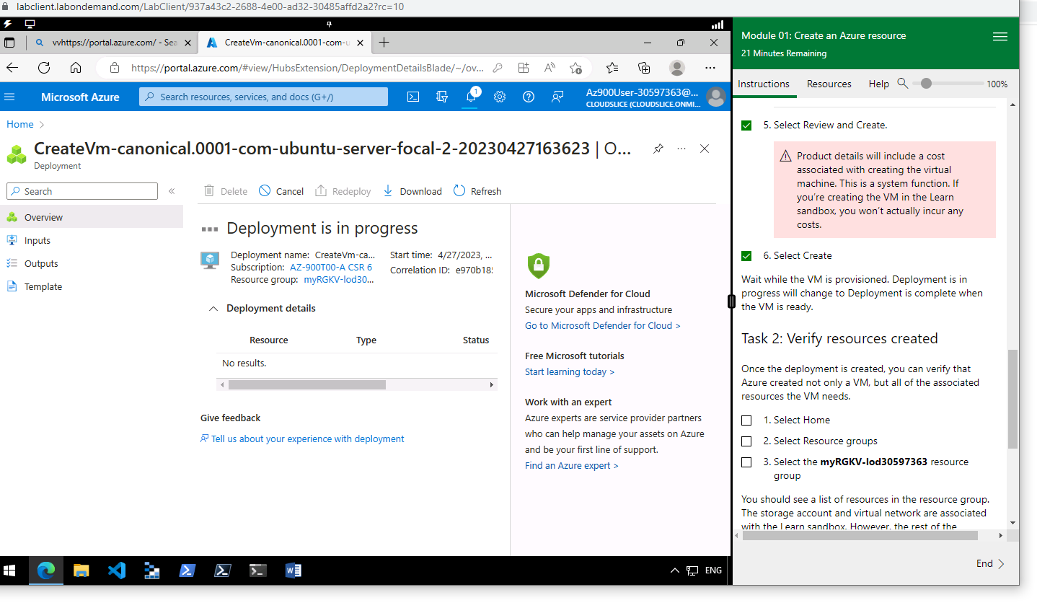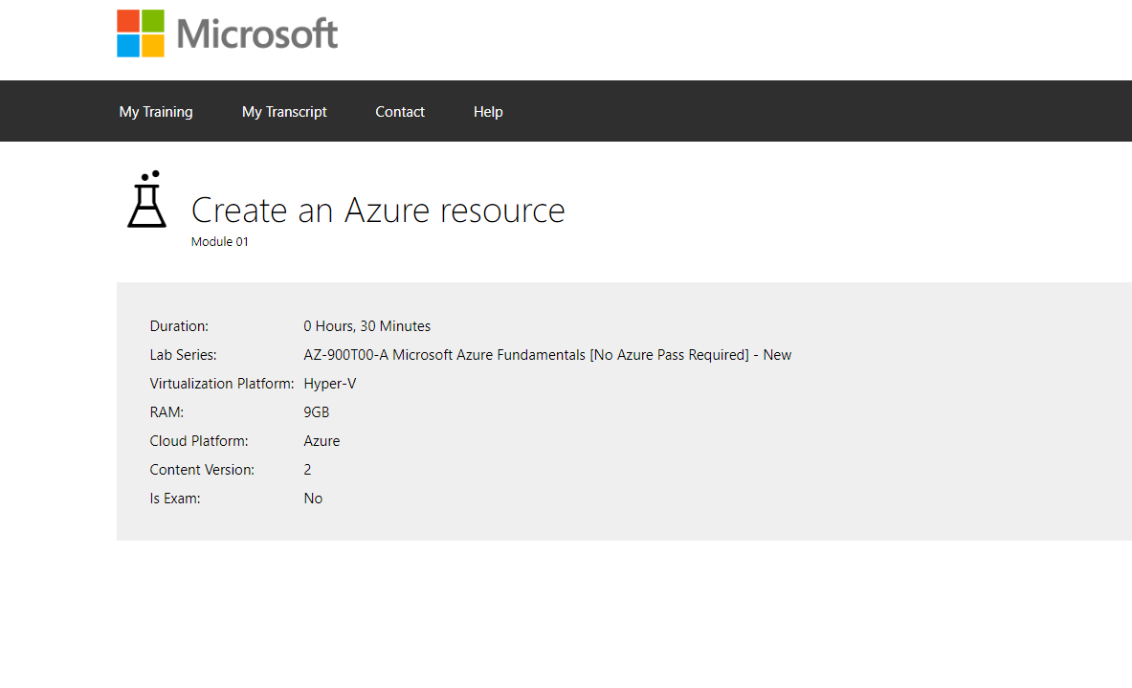

Task 3

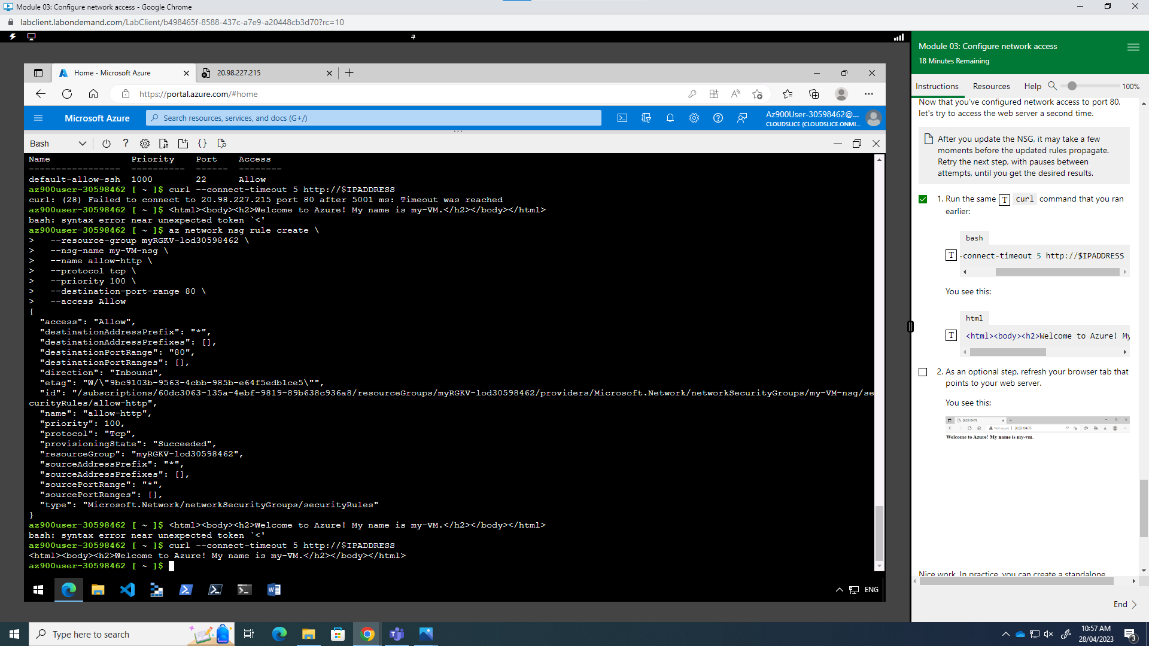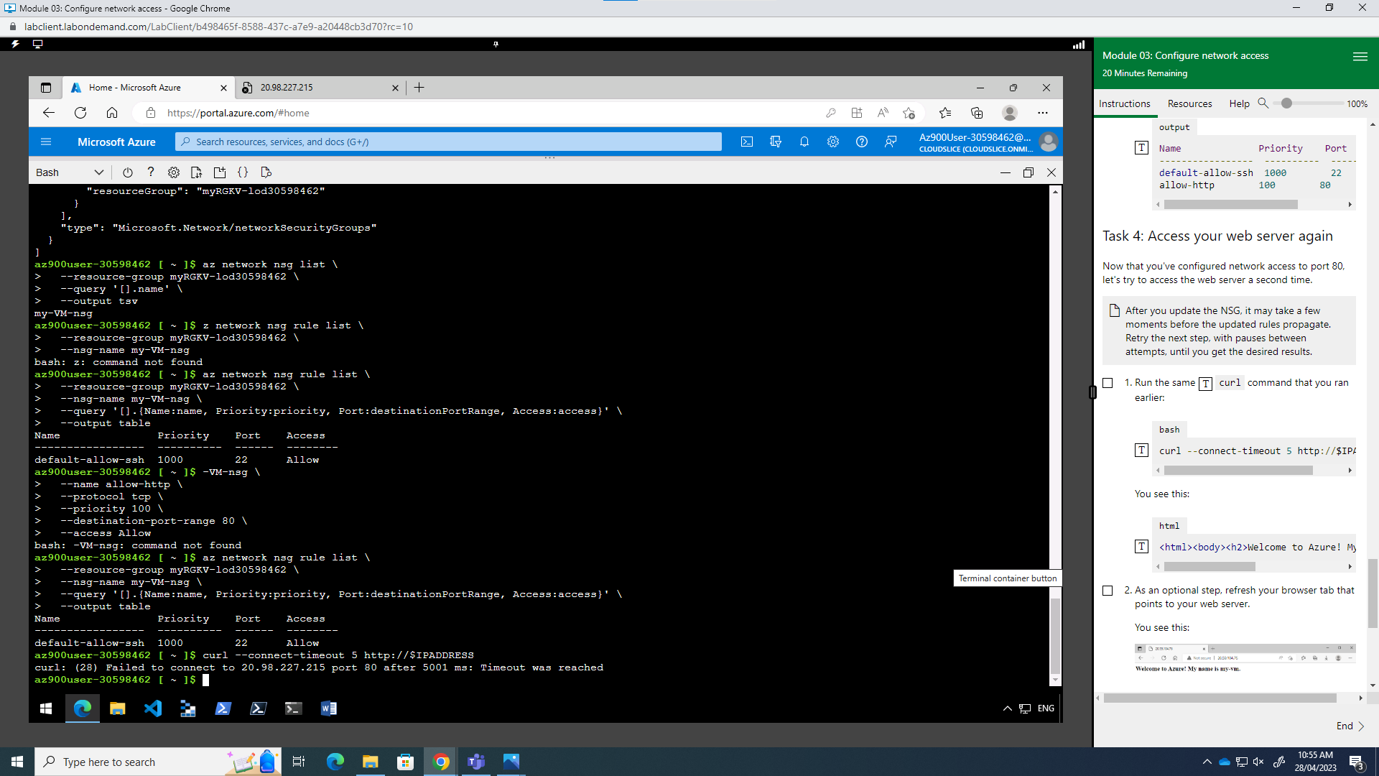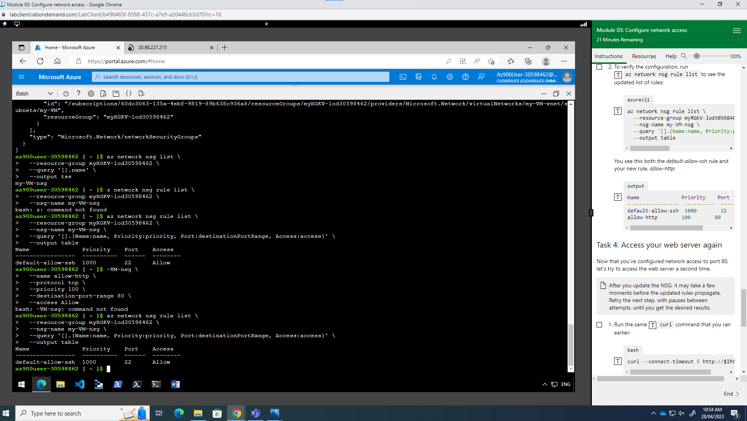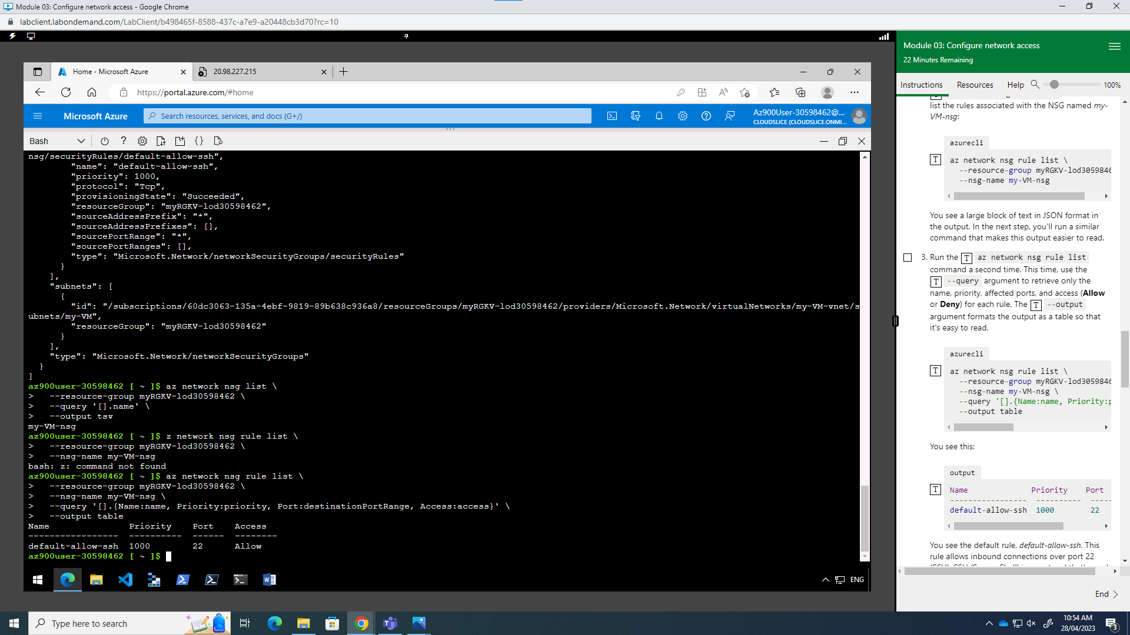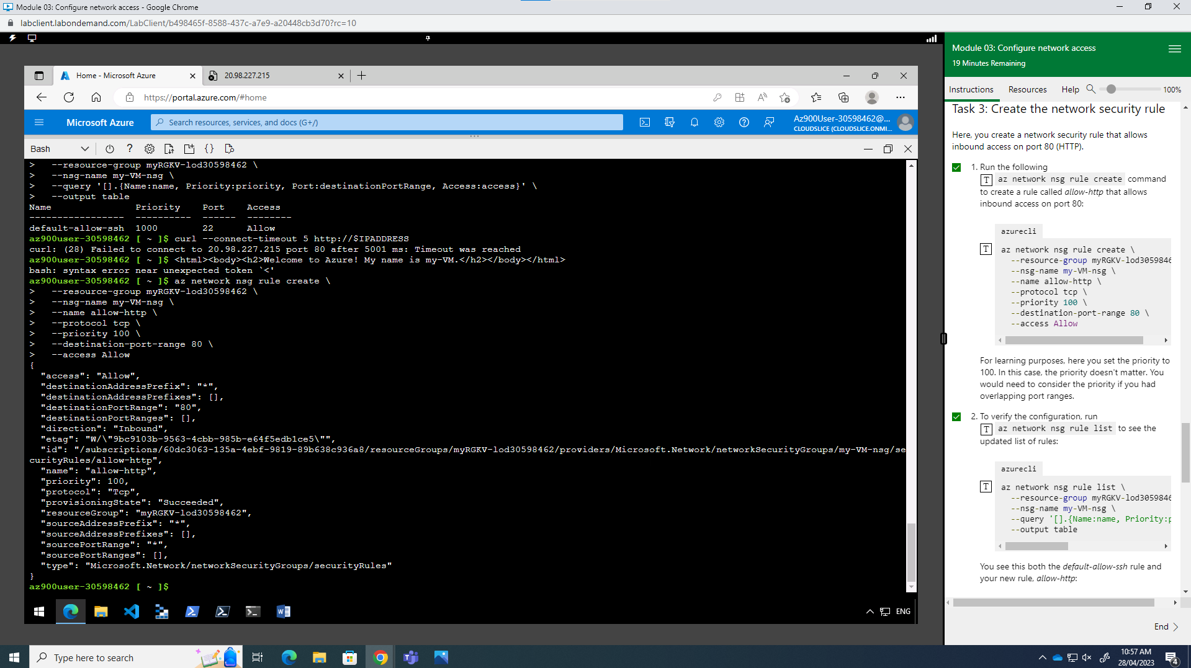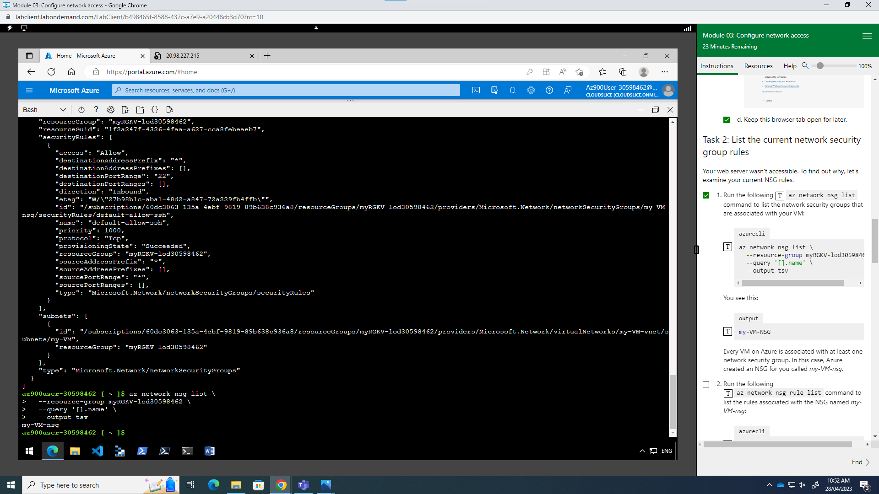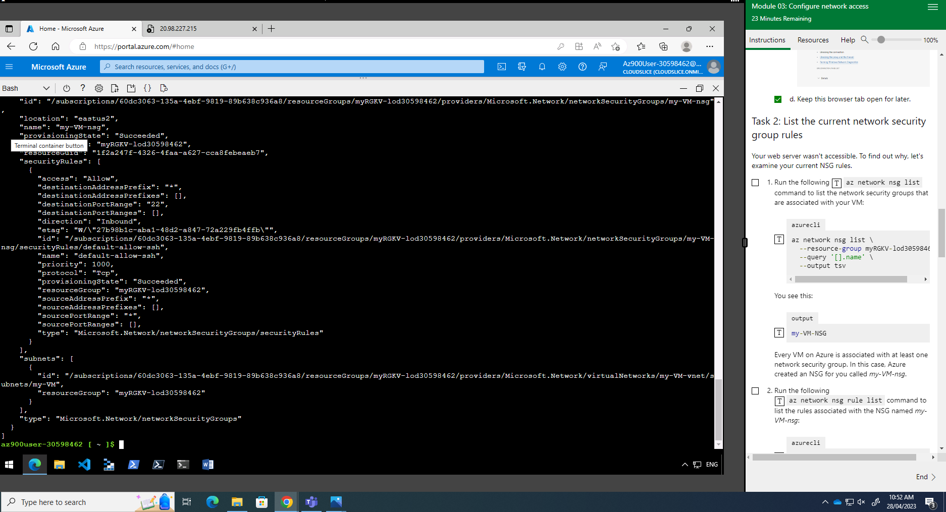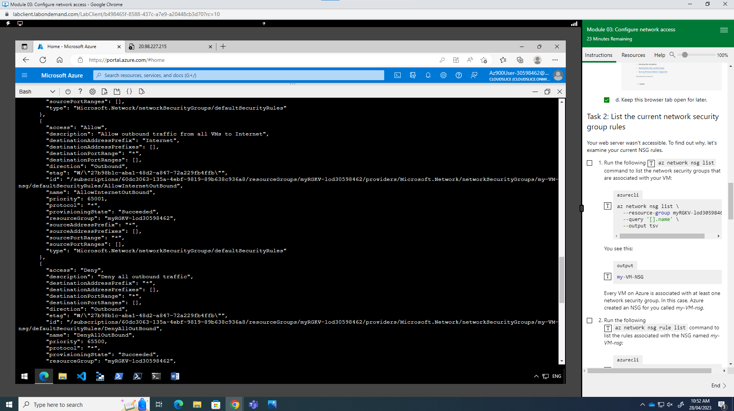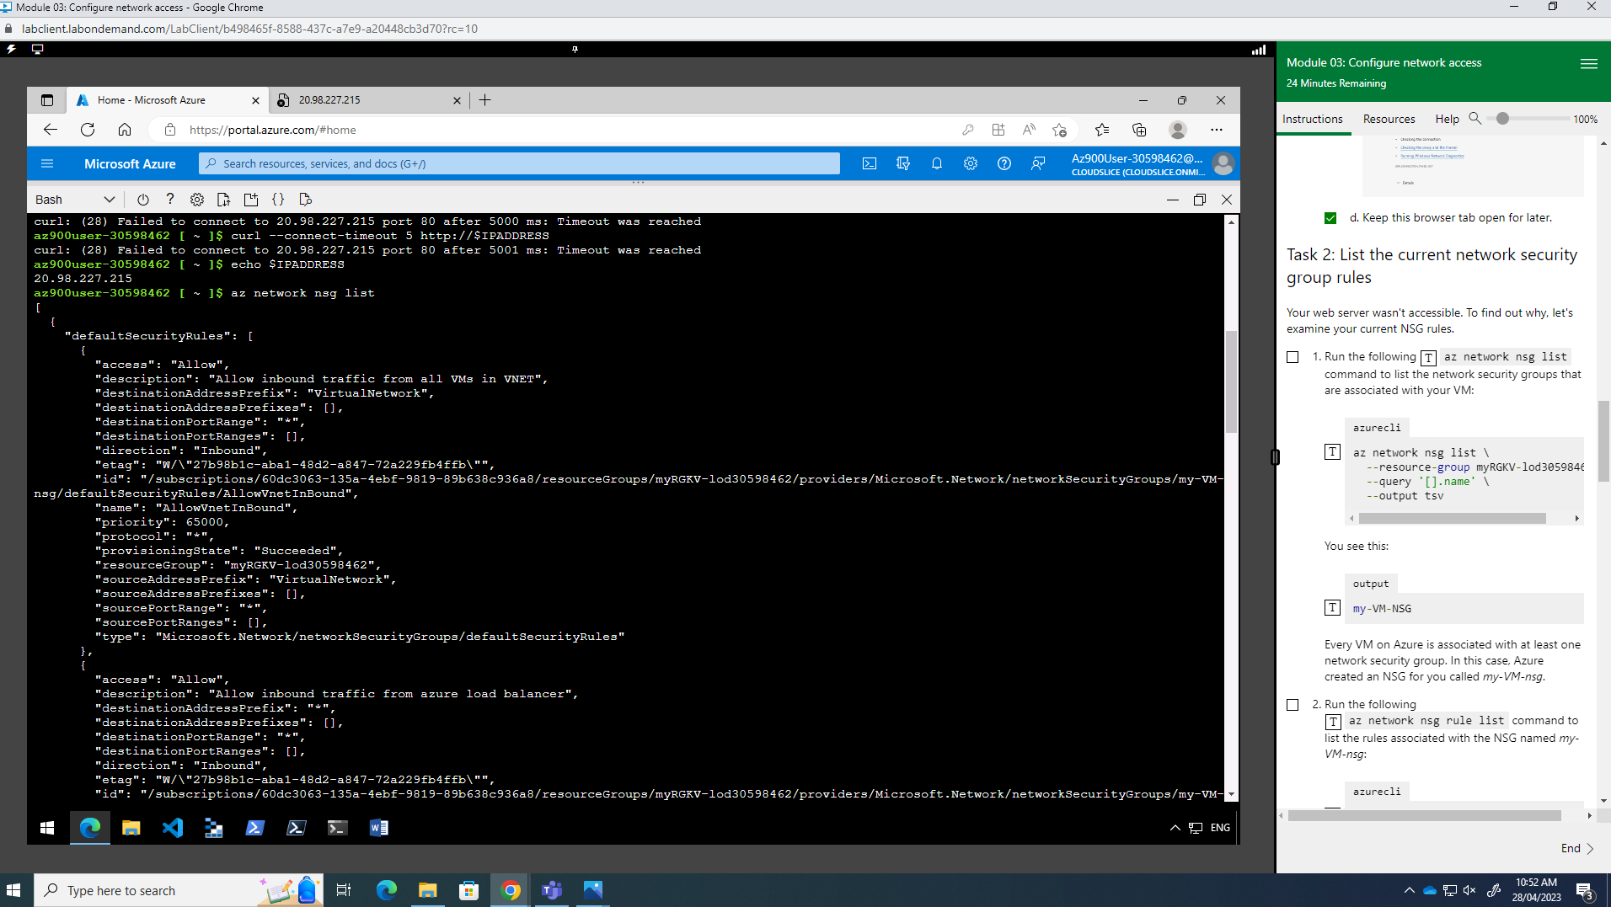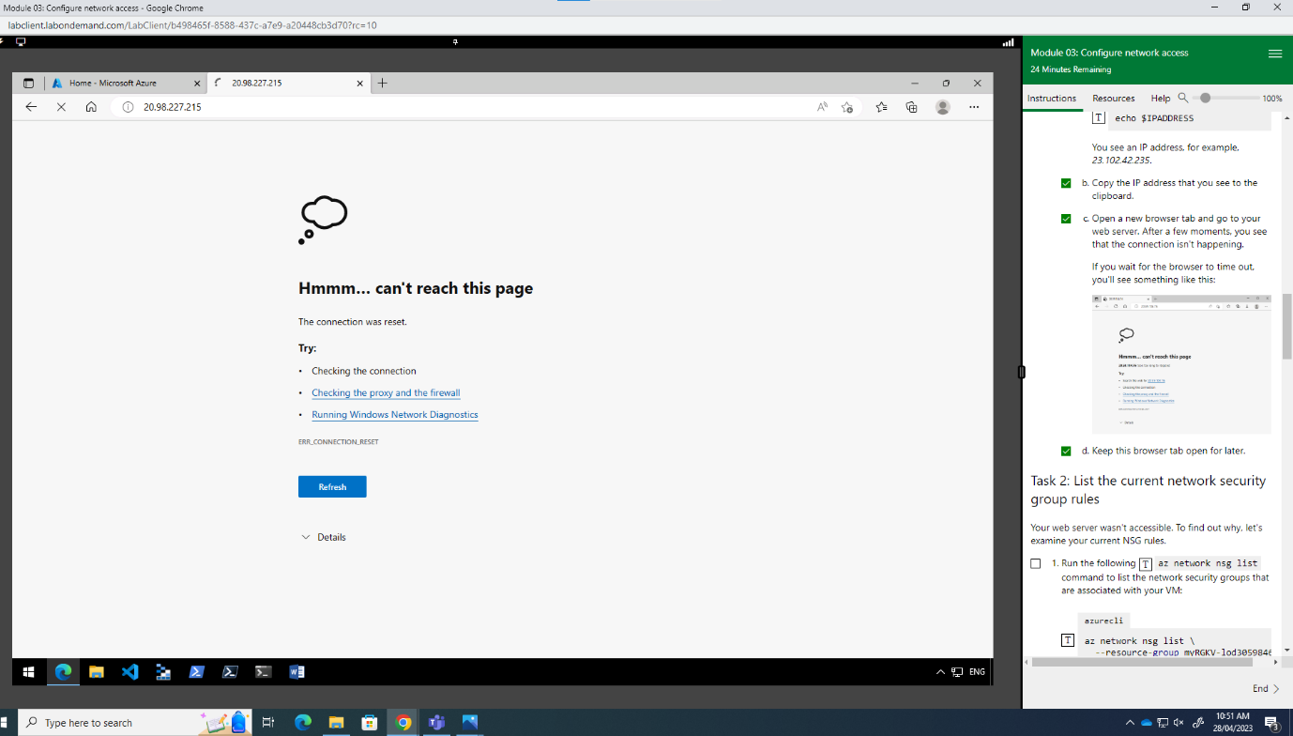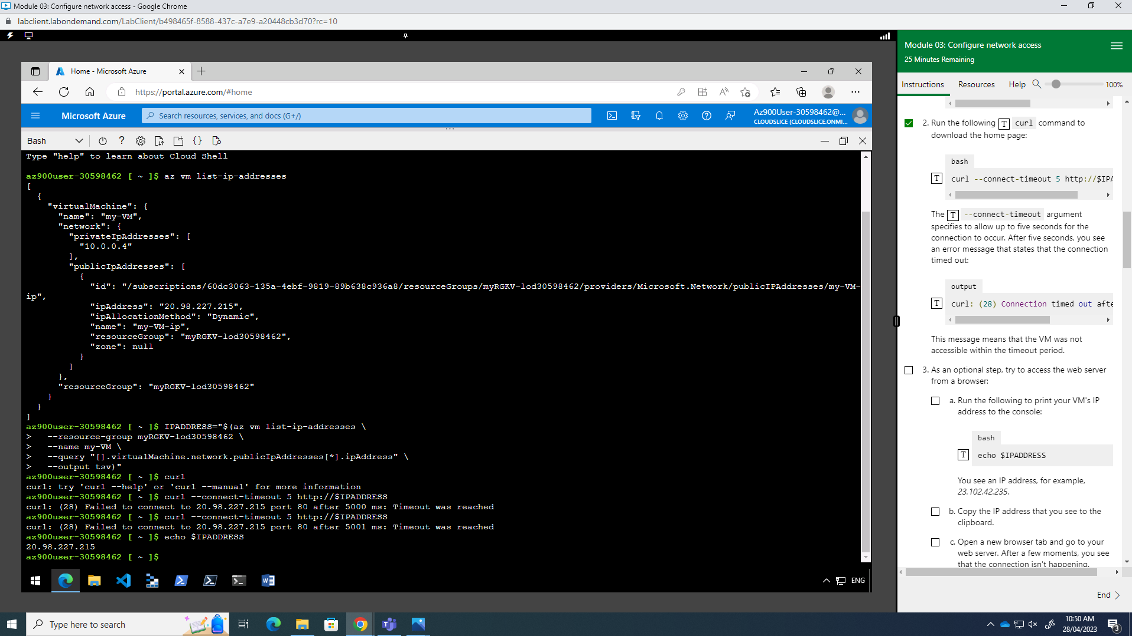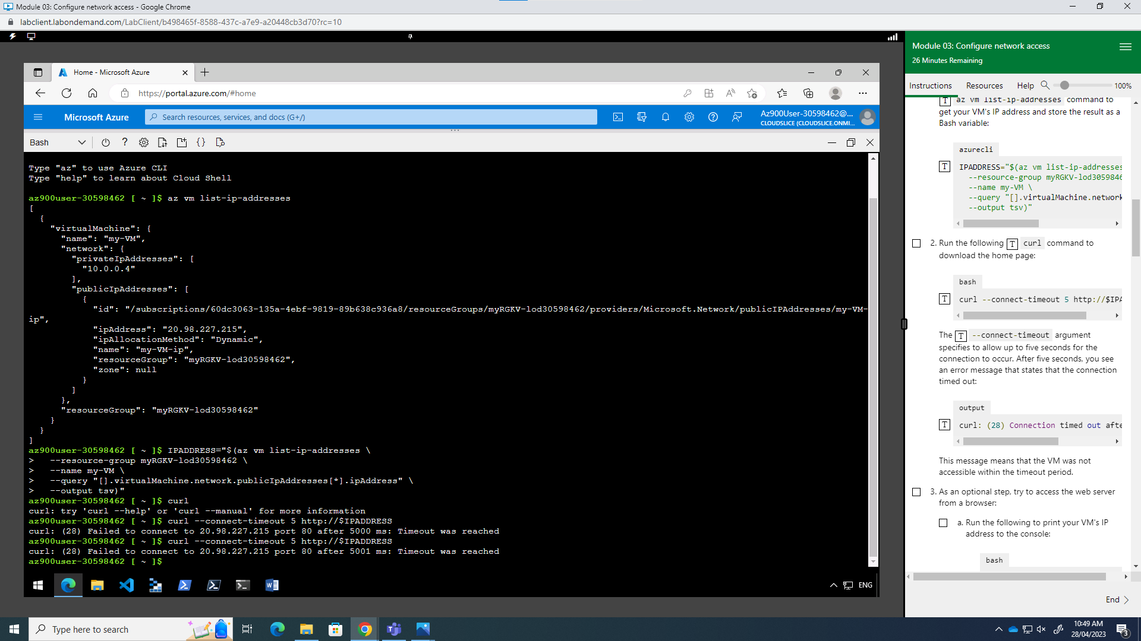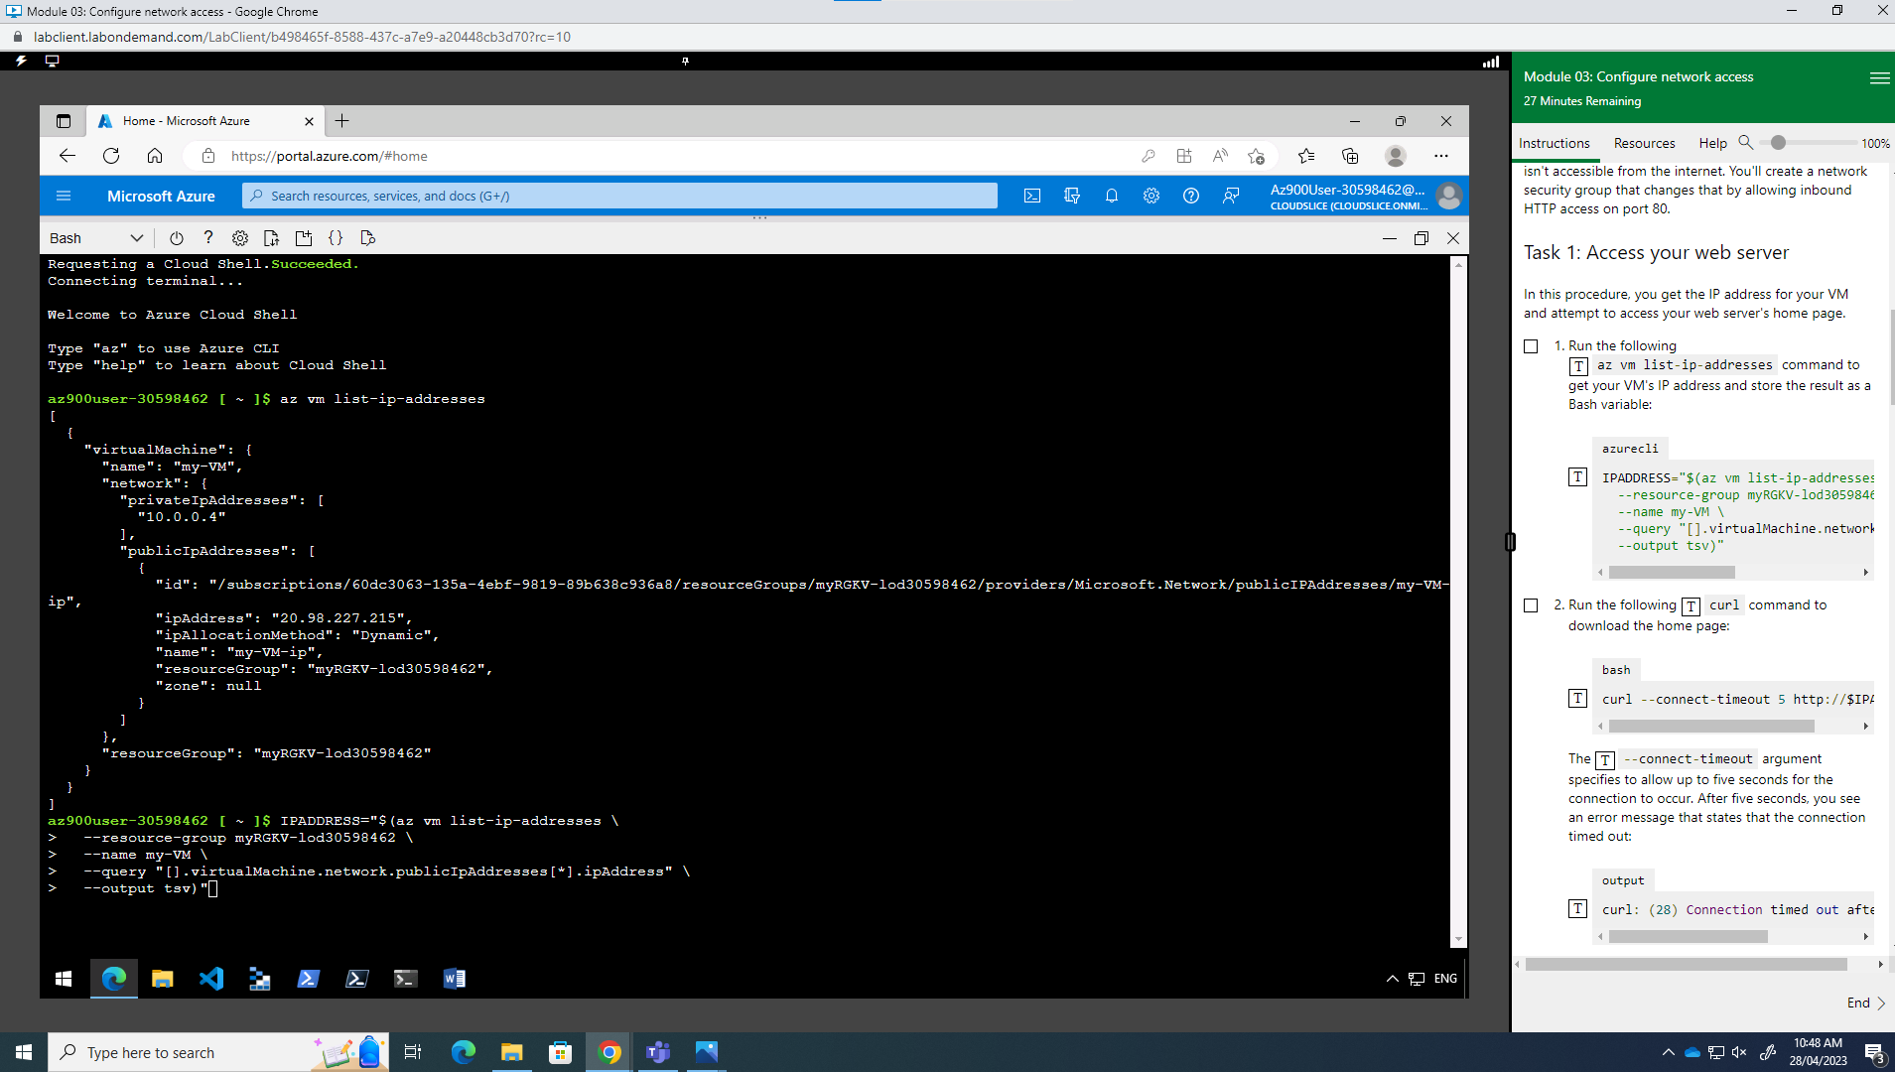

Week 8

**Task -1**

Asset 1: Firewalls

Protection: Securing, Confidential

Reason: Firewalls plays an important role to protect and make data confidential. Moreover, also provide alert from malicious attack which is more useful for server-based company. Having unchanged policies into firewall can help to prevent most of ethical attack.

Asset 2: Cloud (Data storage)

Protection: stored ample amount of data (depends upon cloud server), space availability

Reason: Thanks to AWS system, which helps to delivered this amazing feature. Moreover, also give lots of space to mobile users and company for managing their data space with Backup as well.

Asset 3: Client’s identity

Protection: Circumspection, Honesty

Reason: Consumer’s informative data like their personal details, bank details, important documents and many other aspects can be secure because sometime by just using this information scammer tries to do any illegal activities. In short it help to secure our all information.

Asset 4: Routers, switches, and other devices for networks

Safety: Being able to gain

Reason: Connection gateways and switches allow devices to engage in communication with one another. To maintain persistent connectivity, availability makes sure that the network apparatus is legitimate and willing to appear.

**TASK 2**

Threat source 1: Insiders

Motivation: Insiders may have a variety belonging to explanations, such as irritated employees or workers who are contractors. Retribution, which a revenue stream, or a desire to damage the company in question by disclosing confidential information, changing data, or enforcing with operations are a few of these skills.

The desire for vengeance might lead disgruntled workers who feel they have been wounded or abused by the company to bring harm or disrupt others. This could suggest disclosing private information, corrupting data, or assisting with operations.

Monetary Achievement: Insiders are sometimes driven by the monetary benefits, such as computer hacking or the sale of private information to rivals or the black market. They might take portion of fraud, theft, or unlawfully access to financial systems, among several other activities.

Ideology or Beliefs: Insiders occasionally may be motivated primarily by strong ideologies or religious convictions. They might use their access to systems or data for nefarious purposes, to expose wrongdoing, or to further their own agendas.

Career-related Emerging Issues: Risks to insiders can result from situations where employees experience job insecurity, unhappiness, or fear of layoffs or termination. Future employment security, obtaining power, or taking their vengeance on the company are a few that is feasible motivations.

Situations that present opportunities: Some insiders may give in to temptation or take taking advantage of situations when they come across weaknesses or useful information. This may be motivated by a need for watchfulness, personal greed, or curiosity.

Threat source 2: Advocates or Informants:

Motive: Activists or those who disclose information may target businesses or people in order to reveal wrongdoing, bring pay close attention questions of society or politics, or provide attention to security flaws. The goals they set are influenced by ethical or ideological things to keep in mind.

Cultural or Geopolitical Issues: whistle-blower’s or activists concentrate on particular social, political, or sustainability problems that they firmly believe in. They seek to draw attention to issues like misconduct, corruption, and human rights violations and may Safeguarding of Rights of the nation and Freedoms: Activists or informants may take action to defend the rights and liberties of people or groups they believe are being oppressed or treated unfairly. By disseminating information, they want to spark change or implement improvements.

Protection for Whistle-blowers: whistle-blower’s frequently run the possibility of negative consequences for their acts, such as consequences under the law, job loss, or even personal attacks. protection laws and practises are necessary to promote the revelation of critically important data without fear of retaliation.

Public Awareness and Advocacy: In order to spread their message and raise awareness about the problems they reveal, activists or hackers use media outlets, public forums, or advocacy groups. They want to spur societal change and mobilise the populace. across information that does just that.

morality: Activists and those complaining frequently act out of a sense of duty. They consider it their duty to reveal information that is in the public interest, even if doing so involves breaking accepted customs or legal restrictions.

Transparency and Accountability: The primary goals of these initiatives are to advance transparency and hold people, groups, or governments responsible for their deeds. To expose covert actions or to upset the status quo, they could give away classified or private information.

**Week: 9**

Function: Protect; Classification: A; Subclass: 1

Goal: Identity management and access management

The project's importance: To guarantee that only authorised people can access allergic resources and information in the project, identity management and access control are essential. Attack/Vulnerability Threats from insiders and unauthorised access were mitigated. Access control and identity management procedures assist reduce the risk of data breaches and unauthorised activity by preventing wrongful individuals from accessing vital systems.

Function; B Sub-category 2

**Objective**: Data safeguarding and encoding are essential for the project's goal. To safeguard sensitive information and uphold confidentiality and integrity all while the project, data security and encryption are crucial. Attack/Vulnerability Data breaches and ill-equipped information disclosed were mitigated.

Function: Detect: Subclassification: 3

Monitoring of Anomalies and Events is the goal.

The **project's importance**: The project's systems and networks can be monitored for anomalies and occurrences to help identify shady dealings, odd behaviour, and potential security concerns.

Attack/Vulnerability Mitigated: System invasions and malware infections. The project can detect and respond to abnormalities, signalling potential malware infections, unauthorised access attempts, or other security events, by watching and analysing system logs, network traffic, and user actions.

Perform: subcategory :4

Goal: Incident Management and Response

Importance for the Project: Quickly responding to security issues, reducing their impact, and resuming regular operations depend on effective incident response and management.

Attack/Vulnerability Successful cyberattacks and their effects have been mitigated.

**TASK 2&3**

Sure! Here are tables for different asset types, including Data assets, Software assets, Hardware assets, and Personnel assets, for your project:

|  |  |  |  |
| --- | --- | --- | --- |
| Asset Name | Description | Classification | Important Protections |
| Consumer information | Confidential information | High Value | Confidentiality |
| Income Source | Finance statement | High Value | Confidentiality |
| Planning of project | Required documents | Medium Value | Availability |

Software Assets:

|  |  |  |
| --- | --- | --- |
| **Asset Name** | **Description** | **Important Protections** |
| Web Application | Developing server | Unrestricted access, |
| Database System | Data storage and retrieval | Data Encryption |
| Communication system | Making interaction and cl | Privacy |
| Clouding system | Data storage | Free to aces |

Hardware Assets:

|  |  |  |
| --- | --- | --- |
| **Asset Name** | **Description** | **Important Protections** |
| Server(system) | Client based applications | Face to Face interaction |
| Network Devices | Routers, switches, firewalls | Access Control |
| Storage Devices | Hard drives, backups | Data Encryption |
| Security Cameras | Surveillance equipment | Physical Security |

Personnel Assets:

|  |  |  |
| --- | --- | --- |
| **Asset Name** | **Description** | **Important Protections** |
| System Administrators | Manage IT infrastructure | Client Control |
| Makers | Maintaining Data or servers | Coding practices |
| Project Manager | Oversees project activities | Security Awareness Training |
| Data Observation | project information | Managing Efficiency |

**Week 10**

